**ASSIGNMENT-1**

**1.Scan and find the open ports of 203.163.246.23 ?**

**Nmap:-**

**Nmap is a network scanning and analyzing tool used to find the open ports in a website and to discover the host by analyzing the packets**

**Step 1:-Open the terminal**

**Step 2:-start scan the website in nmap to find the open ports and to scan any vulnerability(there are several commands are there to scan a network and it show the ports is open or filtered)**

**Command:- nmap 203.163.246.23 -p 21**

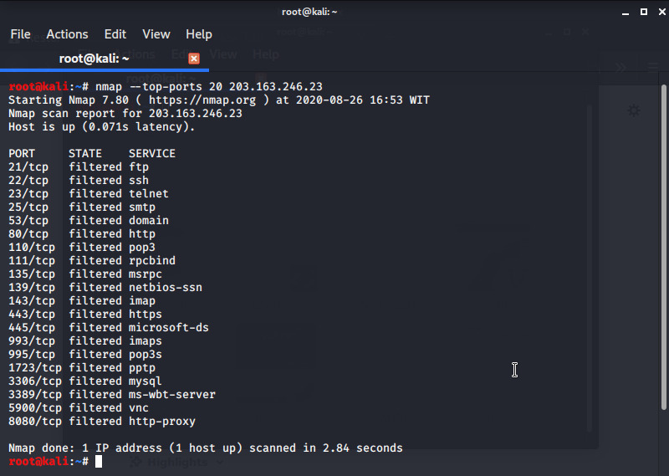

**These command is use to find the particular ports**

**Command:- nmap –Ss 203.163.246.23 -p 1-10**

**These command is also used to find a particular range of time**

**Command:- nmap –Top-ports 20 203.163.246.23**

**----------------------------------------------------------------------**

**2.Find the mail server of the following domain ?**

**Wipro.com**

**IBM.com**

* **Wipro.com**

**Open the terminal and give the command called Nslookup its shows the DNS server of your device and by setting the task we gets the ip address and mail server of the domain**

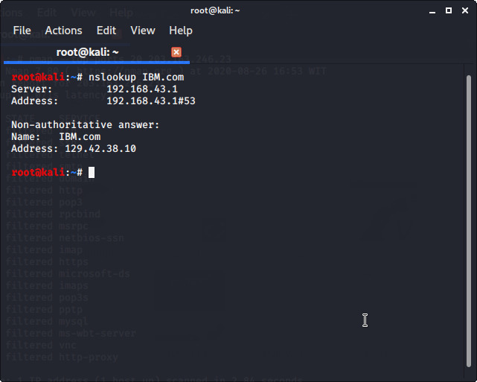

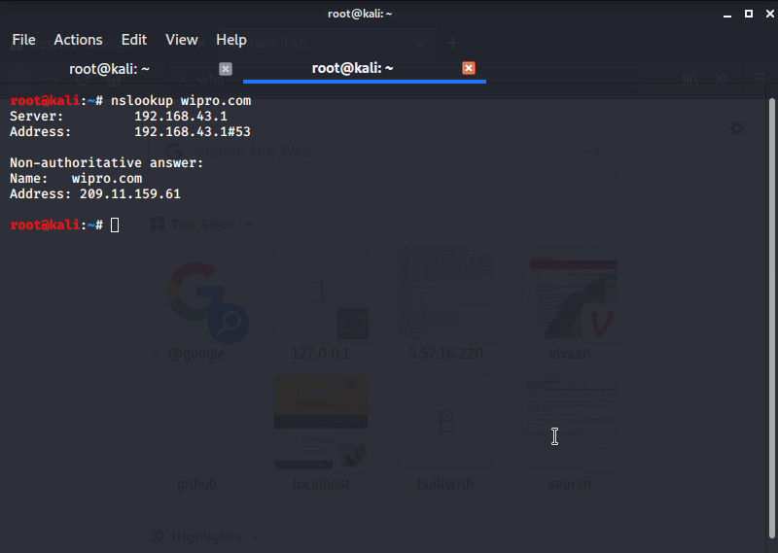

* **IBM.com**

